**Practical No. 1**

**Design a web page that makes use of:**

1. 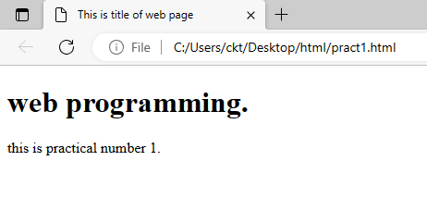**Document Structure Tags**
2. 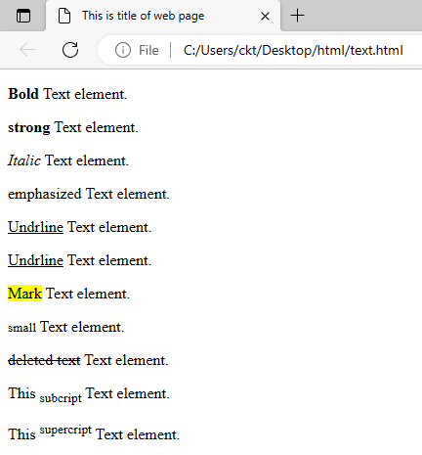**Various text Formatting Tags**
3. 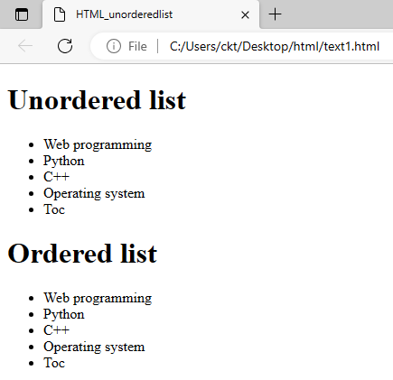**List Tags**
4. 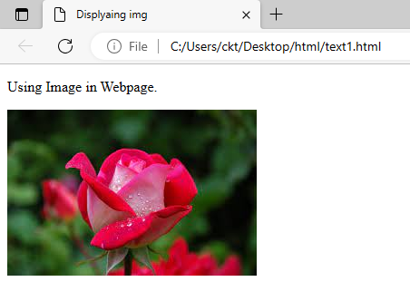**Image and Image Maps**

**Practical No. 2**

**Design a Web Page that makes use of:**

1. **Table Tags**

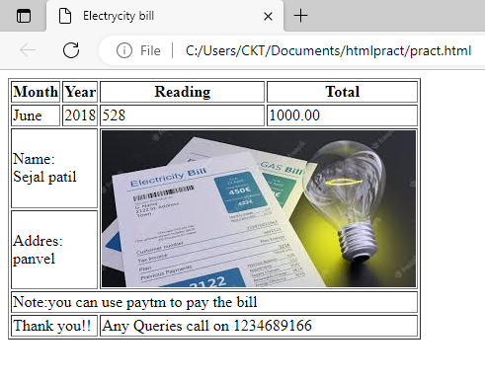

1. 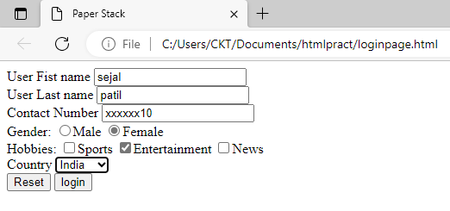**Form Tags (forms with various formeelements)**
2. **Navigation across Multiple Pages**

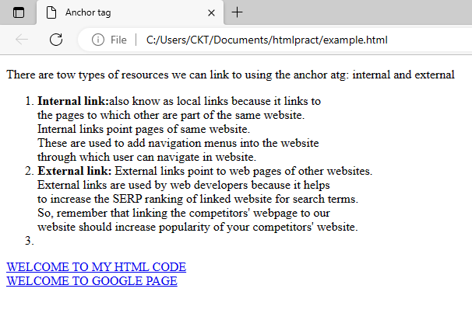

1. **Embedded Multimedia elements**

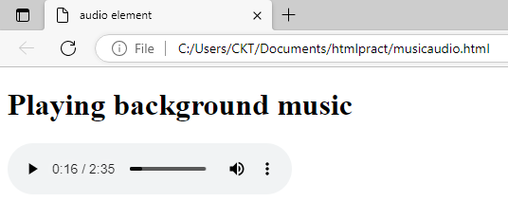

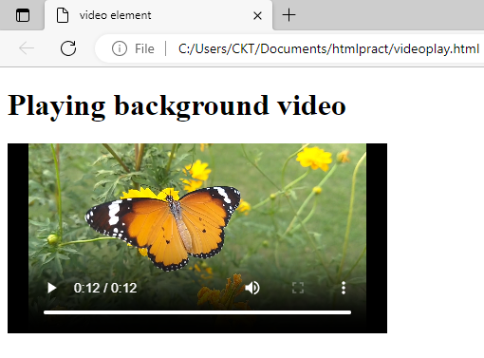

**Practical No. 3**

**Design a javascript program to demonstrate**

1. **External CSS.**

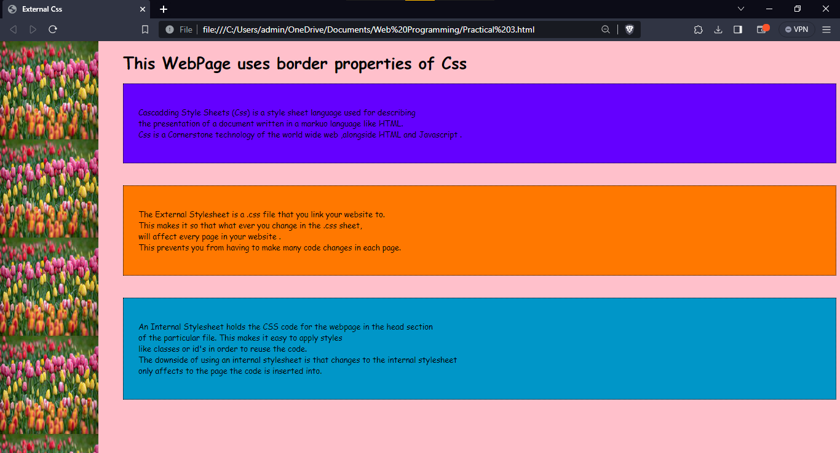

1. **Internal CSS.**

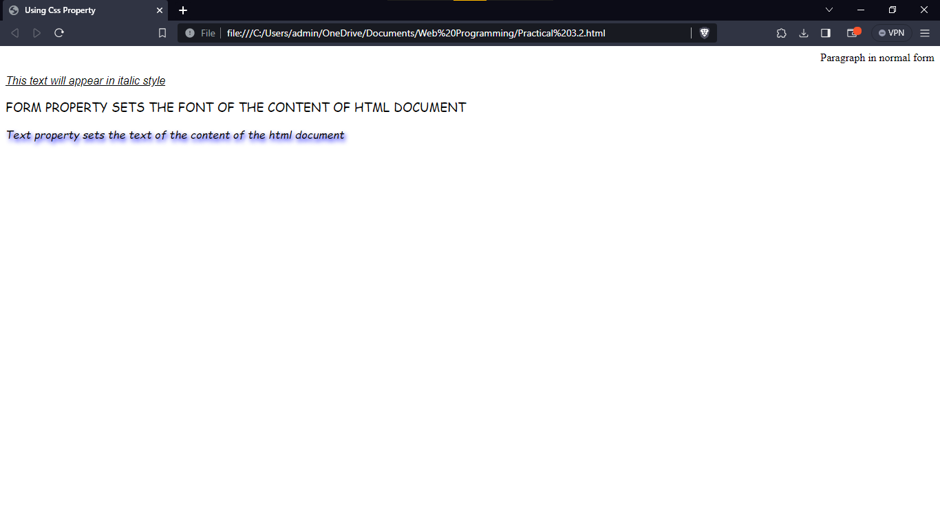

1. **Inline CSS (CSS properties for positioning an element).**

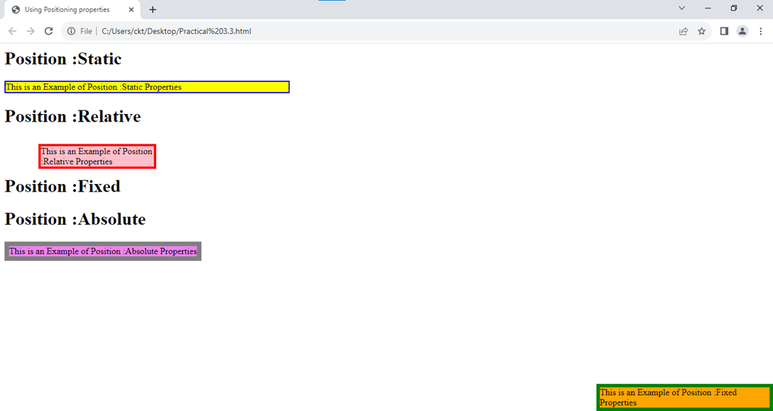

**Practical No. 4**

1. **CSS Properties to change the Background of the Page.**

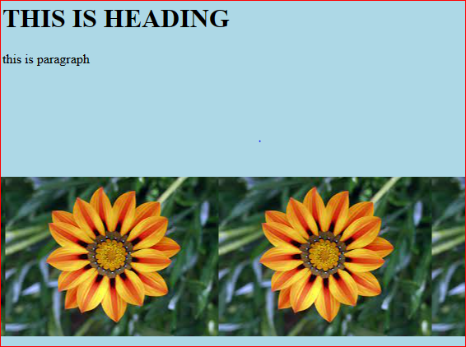

1. **CSS properties to change the Font and text Styles**

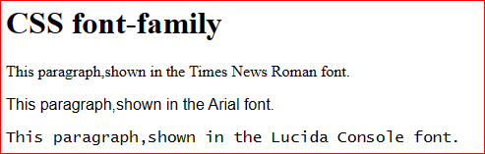 Css font family :

Css font size :

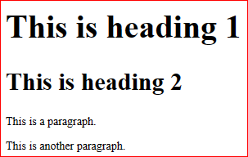

Css font style :

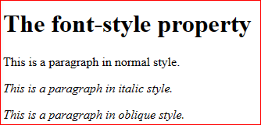

**Practical No. 5**

**Define a JavaScript code for Performing various Mathematical Operations as:**

1. 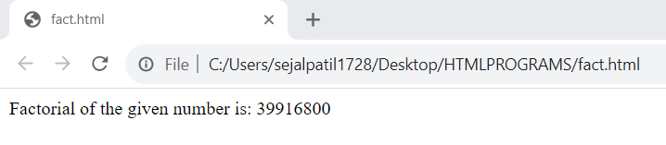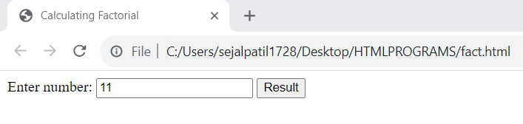**Calculating Factorial**
2. 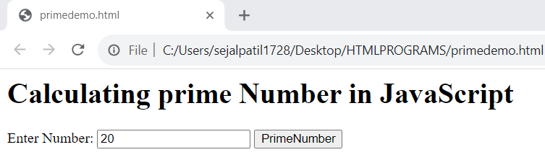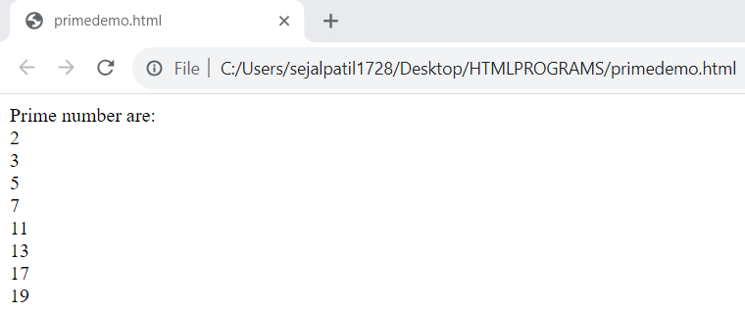**Displaying Prime Numbers**
3. 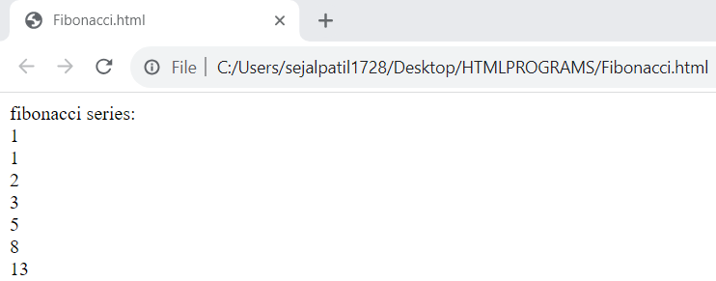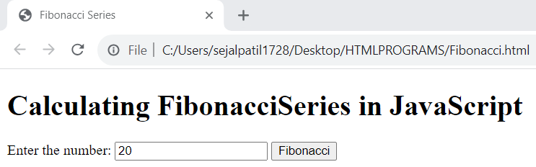**Finding Fibonacci Series**
4. 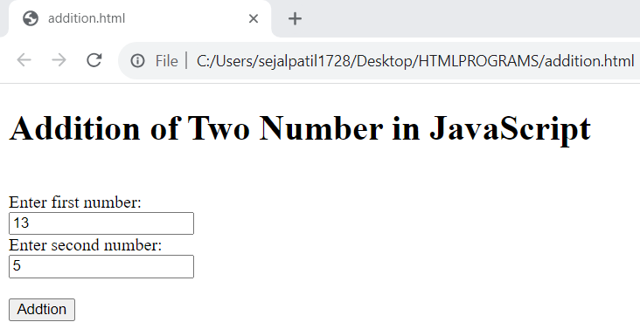**Addition of numbers**

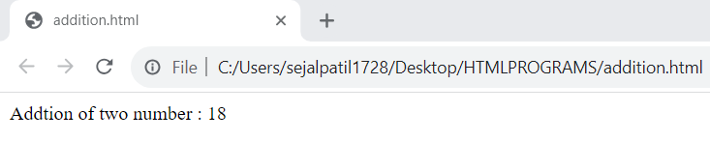

1. 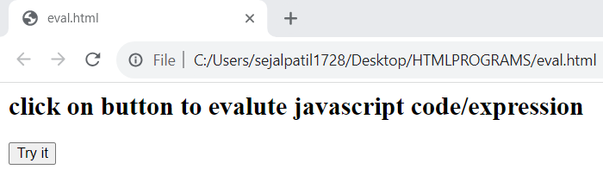**Evaluating Expressions using eval() function**

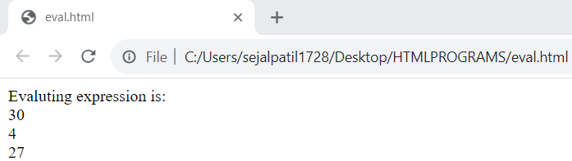

1. **Calculating Reverse of the number**

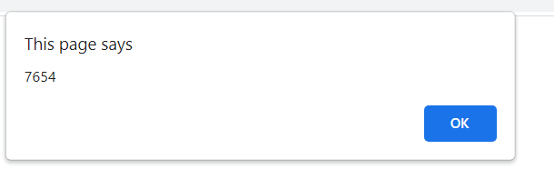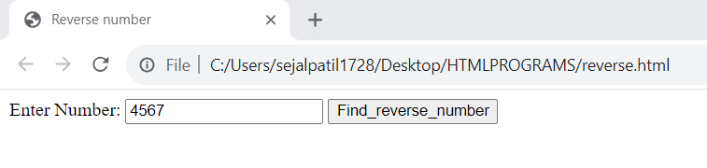

**Practical No. 6**

**Design a JavaScript code for Performing various Validation Operations such as:**

1. **Number Validation**

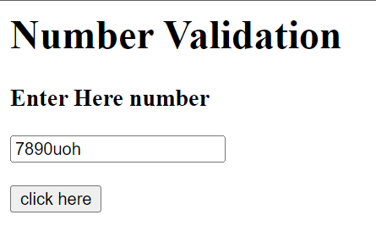If I enterded invalid number which is combination of letter and number then 

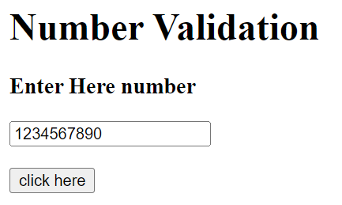After entered correct number



1. **Password Validation**

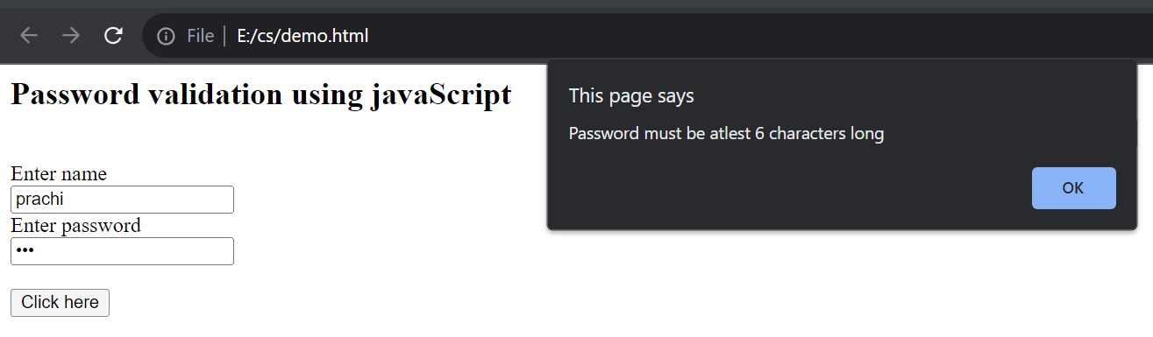When I entered password below the given limit

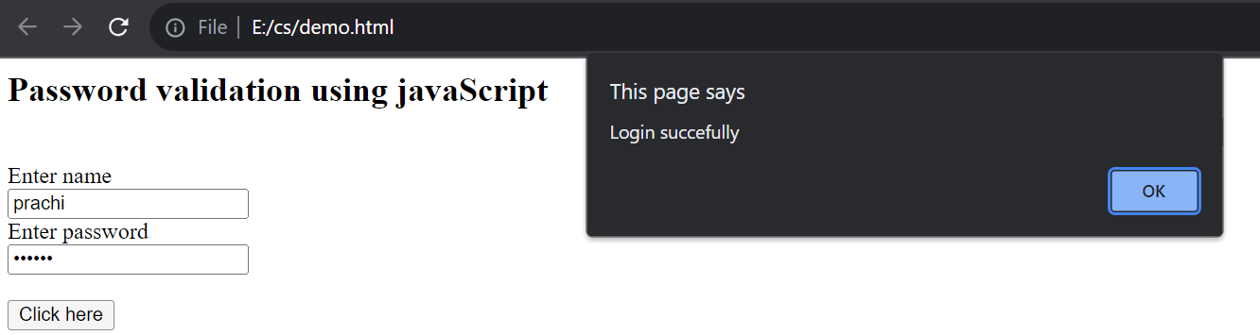

After entered correct password

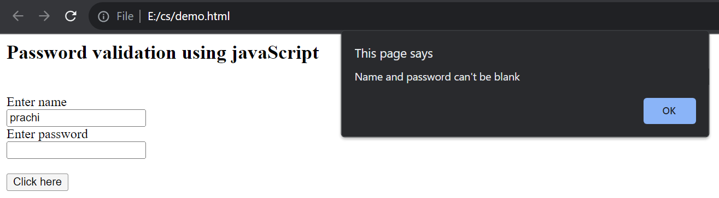 Only entered name then

1. **Re-Pass Validation**

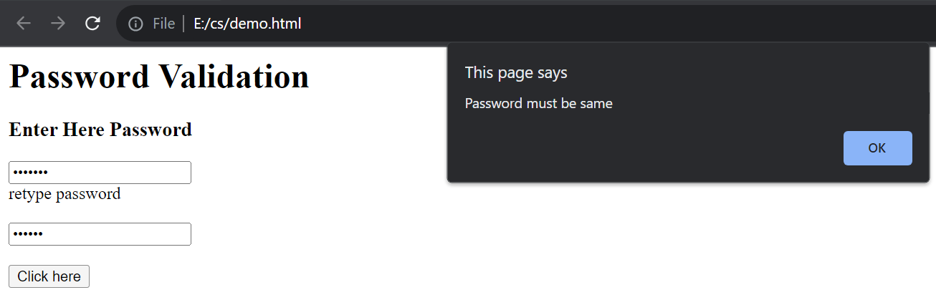When password is not same

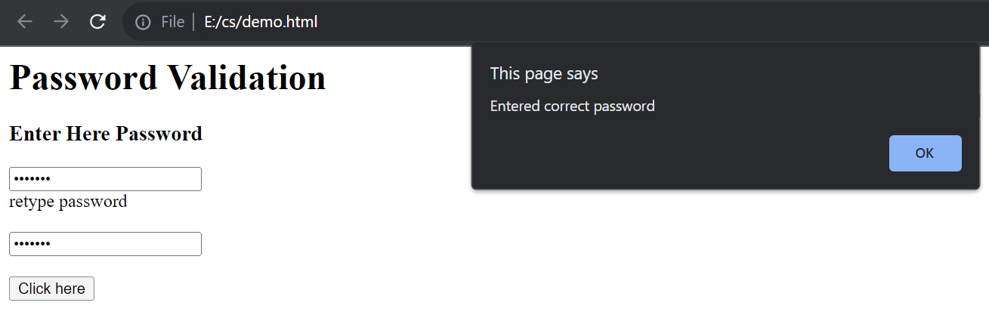When password is match

1. **E-mail Validation**

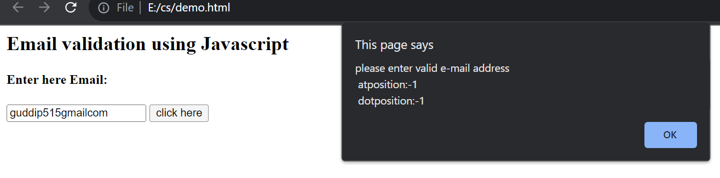when entered invalid email

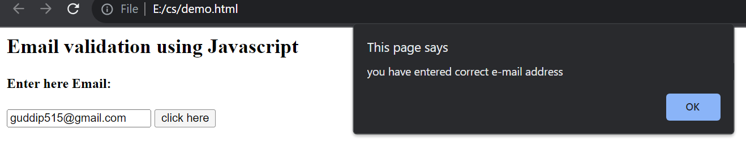And when entered correct email address

1. **Phone Number Validation**

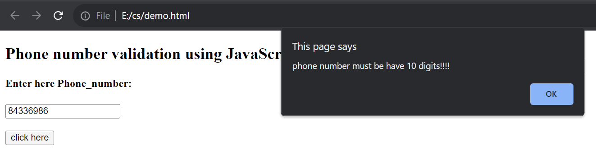When entered invalid number

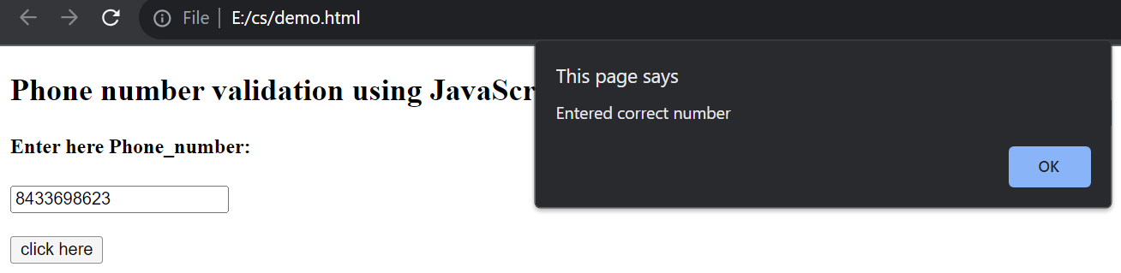

When entered correct number

**Practical No. 7**

1. **Demonstrate JavaScript Objects such as Strings/ Regular Expression/ Math/Date.**

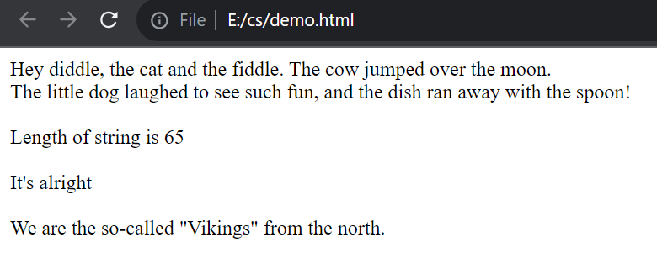Strings

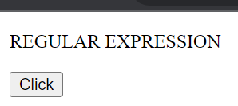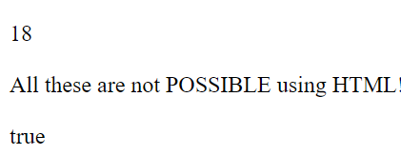Regular expression

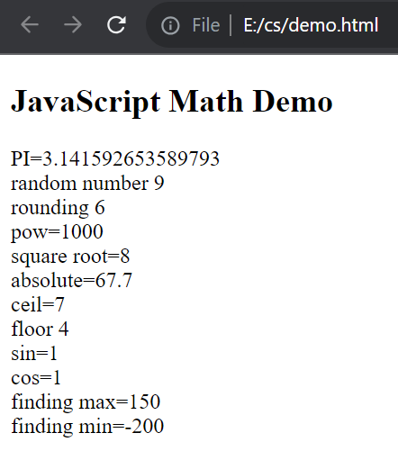Math

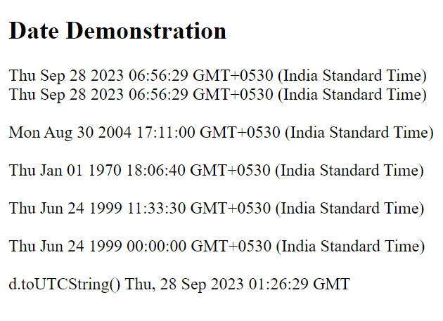Date

1. 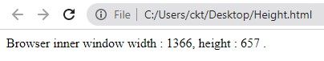**Demonstrate JavaScript Objects such as Window/ Navigator/ History/Location/ Document**

window

navigator

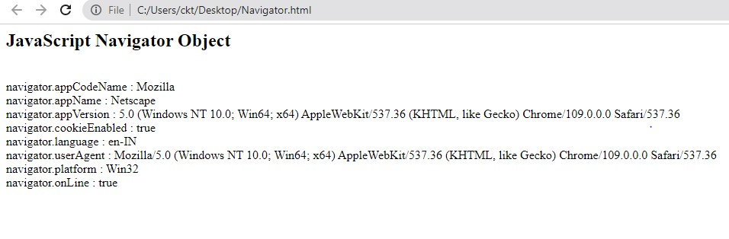

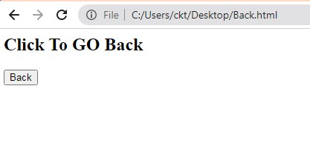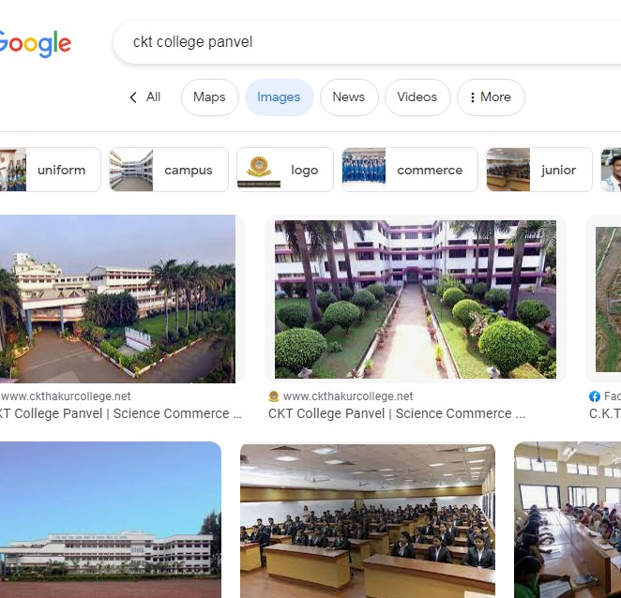History



location

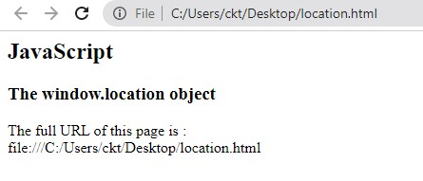

Document

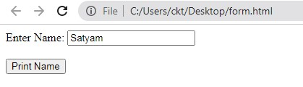

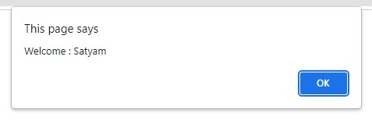

**Practical No. 8**

**Design JavaScript program for Storing and Returning Cookies**

1. 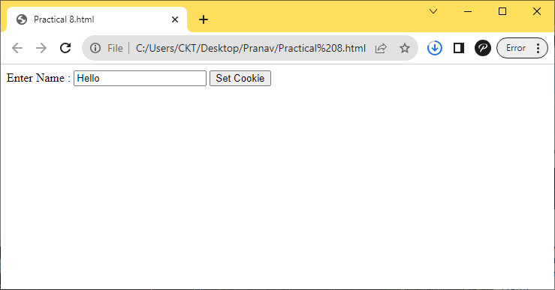

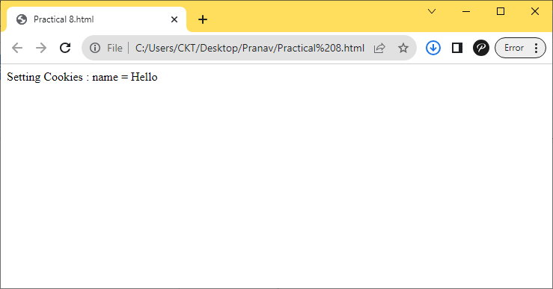After clicking on set cookie button:

1. 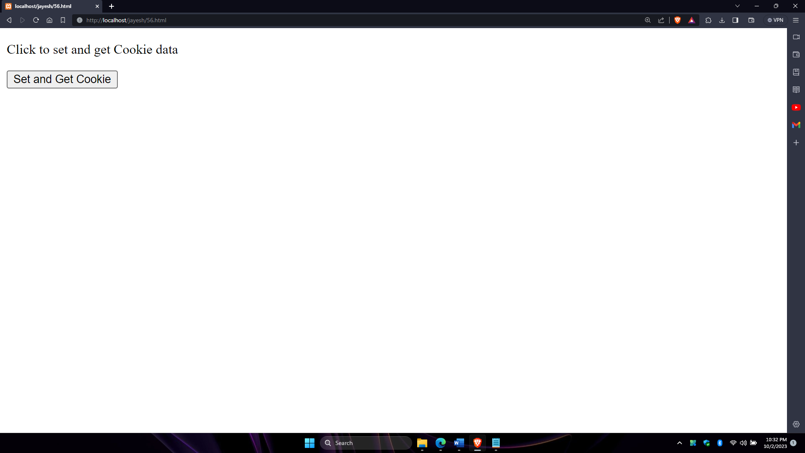

**After clicking on the get cookie button(vamp server has to be connect and run the file from root)**

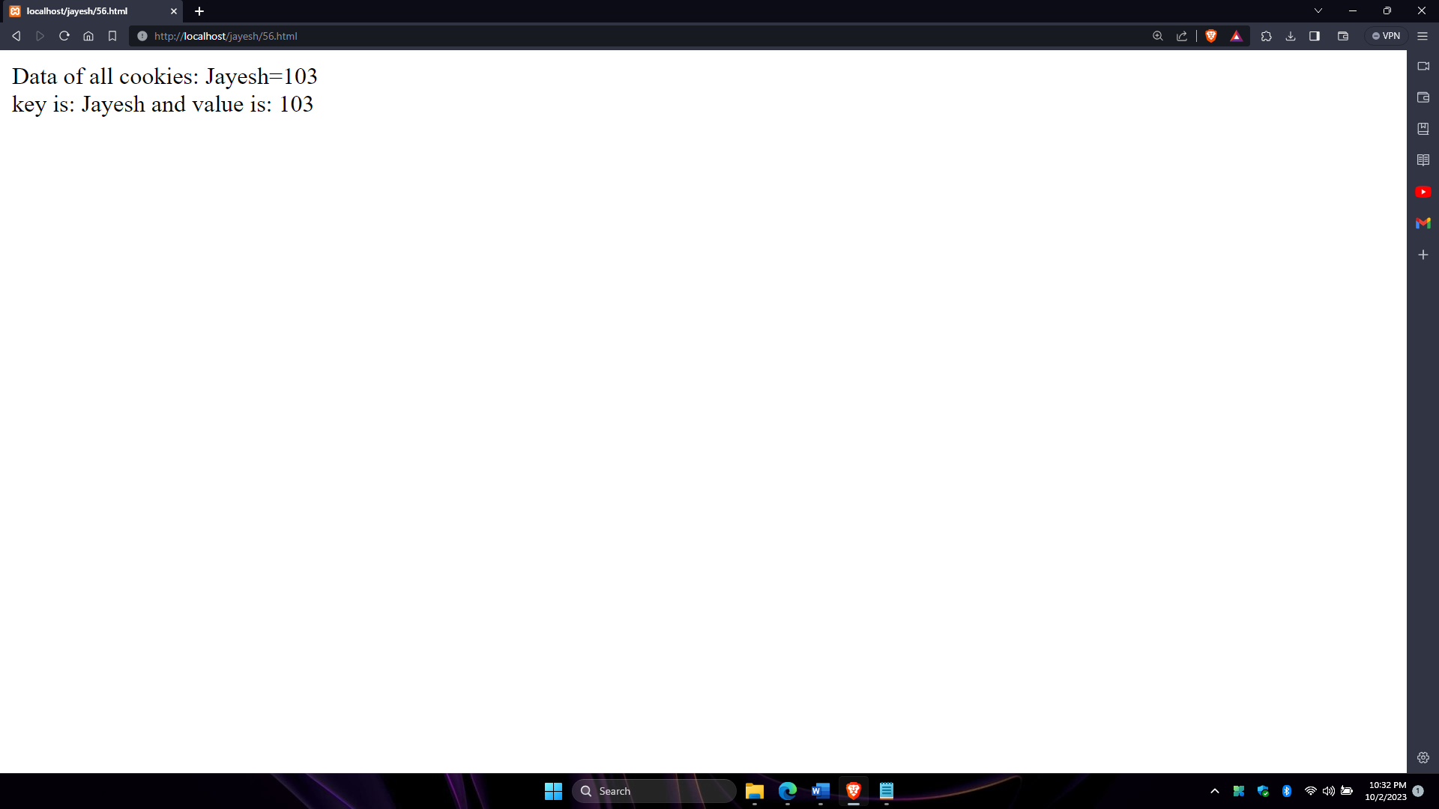

**Practical No. 9**

**Create a XML file with Internal/External DTD and display it using**

**a. CSS**

**b. XSL**

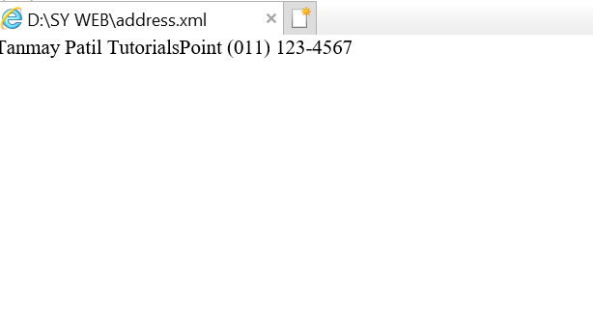

**PRACTICAL NO: 10**

**AIM: Design a web page to handle asynchronous request using AJAX.**

1. **On onclick event**

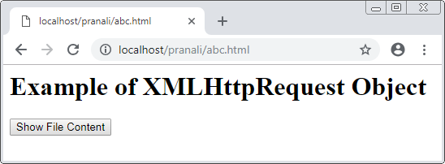

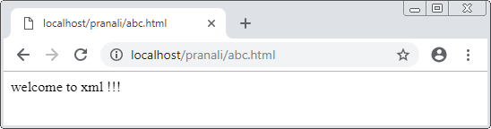

1. **On mouseover event.**



**PRACTICAL NO: 11**

**AIM: Write PHP script for**

1. **Retrieving data from HTML forms**

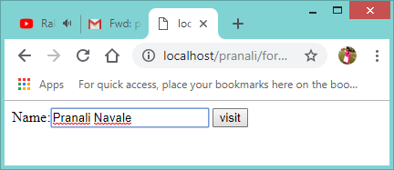

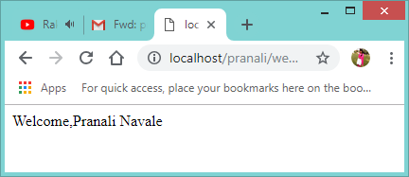

1. 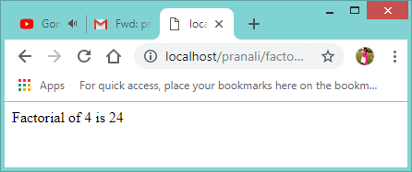**Performing certain mathematical operations such as calculating factorial / finding Fibonacci series / displaying given number is prime or not/ evaluating expressions / calculating reverse of a number.**

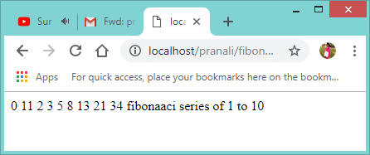

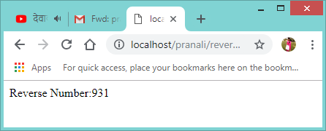

**Practical no.12**

**Design PHP Script for:**

1. **Working with array**

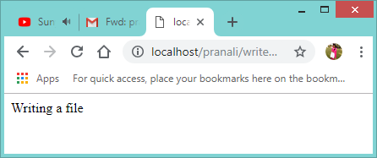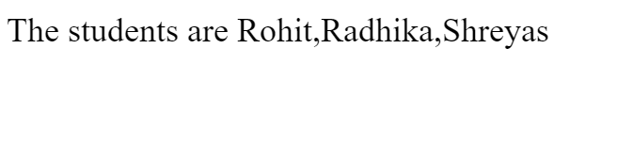

1. **Working with files(reading/writing)**

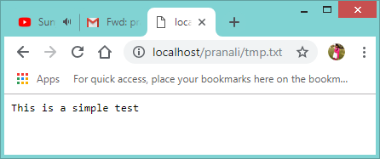

1. **file reading:**

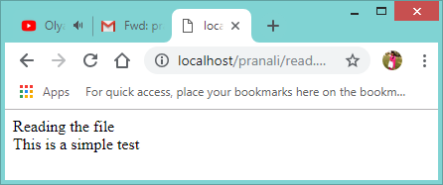

**PRACTICAL NO: 13**

**Aim: Write a PHP program to create a database named “college” .Create a table named “student “ with following fields(sno, sname, percentage). Insert 3 records of your choice. Display the name of the students whose percentage is between 35 to 75 in a tabular format.**

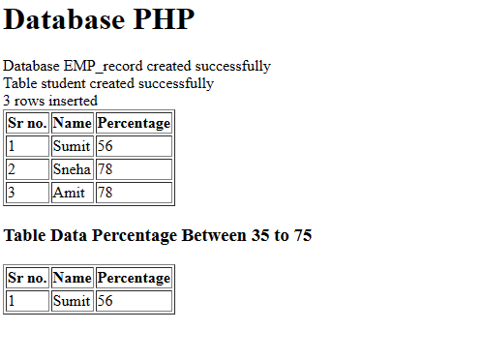

**Practical No:14**

**Aim: Design PHP Scripts for**

1. **Storing & retriewing Cookies**

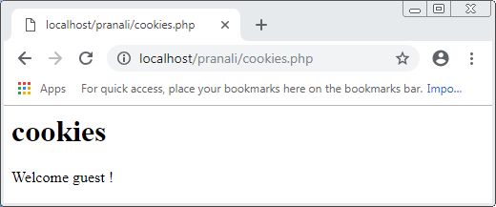

1. 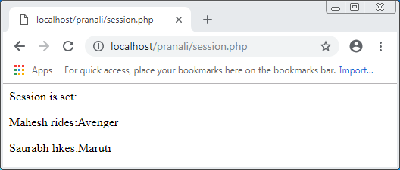**Storing & retrieving sessions**

**PRACTICAL NO: 15**

**Aim: Design a Web Page with some jQuery Animation Effects.**

